

**COMP3900 Project Proposal**

Group: 3900-W14B-Three Days to See

04/03/2022

[Scrum Master]**Yuhan YAN** Front-End z5270656 [z5270656@unsw.edu.au](mailto:z5270656@unsw.edu.au)

[Group Members]

**Xingyu TAN** Front-End z5237560 [xingyu.tan@student.unsw.edu.au](mailto:xingyu.tan@student.unsw.edu.au)

**Anbang CHENG** Back-End z5237233 [z5237233@ad.unsw.edu.au](mailto:z5237233@ad.unsw.edu.au)

**Haofu CHEN** Back-End z5237481 [z5237481@ad.unsw.edu.au](mailto:z5237481@ad.unsw.edu.au)

**Jiajun LI** Back-End z5237312 [z5237312@ad.unsw.edu.au](mailto:z5237312@ad.unsw.edu.au)

Contents

1 Background 5

1.1 Motivation 5

1.2 Problem Statement 6

1.3 Competitive Analysis 7

1.3.1 Steam 7

1.3.2 Humble Bundle 8

2. Epics and User Stories 10

2.1 Epic1: Client Account 10

2.1.1 Register for basic information (estimated difficulty: 3/5; time estimate: 10 h) 10

2.1.2 Register with interest questionnaire (estimated difficulty: 3/5; time estimate: 10 h) 11

2.1.3 Login (estimated difficulty: 2/5; time estimate: 6 h) 12

2.1.4 Forget password (estimated difficulty: 3/5; time estimate: 10 h) 13

2.1.5 Logout (estimated difficulty: 1/5; time estimate: 3 h) 13

2.2 Epic2: Customer Profile 13

2.2.1 Reset Password (estimated difficulty: 2/5; time estimate: 6 h) 14

2.2.2 View Profile (estimated difficulty: 3/5; time estimate: 10 h) 14

2.2.3 Payment Options (estimated difficulty: 2/5; time estimate: 6 h) 15

2.3 Epic3: Browse website 16

2.3.1 Home Page (estimated difficulty: 4/5; time estimate: 15 h) 16

2.3.2 Product Details Page (estimated difficulty: 4/5; time estimate: 15 h) 17

2.4 Epic4: Search website 18

2.4.1 Sort Filter (estimated difficulty: 4/5; time estimate: 15 h) 18

2.4.2 Search box (estimated difficulty: 3/5; time estimate: 10 h) 19

2.5 Epic5: Order 20

2.5.1 Order Details page (estimated difficulty: 3/5; time estimate: 10 h) 20

2.5.2 History Order Page (estimated difficulty: 3/5; time estimate: 10 h) 21

2.5.3 Rate (estimated difficulty: 2/5; time estimate: 6 h) 22

2.5.4 Comment (estimated difficulty: 2/5; time estimate: 6 h) 23

2.6 Epic6: Cart 24

2.6.1 View Cart Products (estimated difficulty: 3/5; time estimate: 10 h) 24

2.6.2 Add Item (estimated difficulty: 2/5; time estimate: 6 h) 25

2.6.3 Delete Item (estimated difficulty: 2/5; time estimate: 6 h) 25

2.7 Epic7: Payment 26

2.7.1 Checkout (estimated difficulty: 3/5; time estimate: 10 h) 26

2.8 Epic8: Recommendation 27

2.8.1 Recommendation (estimated difficulty: 5/5; time estimate: 20 h) 27

2.8.2 Recommendation in carousel & other place (estimated difficulty: 5/5; time estimate: 20 h) 28

2.9 Epic9: Surprise Store (Novel feature) 28

2.9.1 Surprise Store (estimated difficulty: 5/5; time estimate: 20 h) 28

2.10 Epic10: Personalized Lottery (Novel feature) 29

2.10.1 Personalized Lottery (estimated difficulty: 5/5; time estimate: 20 h) 29

2.11 Epic11: Admin Account 30

2.11.1 Login (estimated difficulty: 2/5; time estimate: 6 h) 30

2.11.2 Logout (estimated difficulty: 1/5; time estimate: 3 h) 31

2.11.3 Admin management (estimated difficulty: 3/5; time estimate: 10 h) 31

2.11.4 Register and Delete Admin (estimated difficulty: 2/5; time estimate: 6 h) 32

2.12 Epic12: Sales information 33

2.12.1 View the Overall Sales (estimated difficulty: 3/5; time estimate: 10 h) 33

2.12.2 Order Information (estimated difficulty: 3/5; time estimate: 10 h) 34

2.13 Epic13: Products Management 35

2.13.1 View Product (estimated difficulty: 2/5; time estimate: 6 h) 35

2.13.2 Add Product (estimated difficulty: 2/5; time estimate: 6 h) 37

2.13.3 Edit Product (estimated difficulty: 2/5; time estimate: 6 h) 38

2.13.4 Replenishment (estimated difficulty: 3/5; time estimate: 10 h) 38

2.13.5 Remove Product (estimated difficulty: 1/5; time estimate: 3 h) 38

3.Sprint 40

3.1 First Sprint 40

3.1.1 First Sprint Backlog 41

3.2 Second Sprint 44

3.2.1 Second Sprint Backlog 45

3.3 Third Sprint 46

3.3.1 Third Sprint Backlog 47

3.4 Backlog Total 48

4. Technical depth, scale, report formatting 50

4.1 Interface and flow diagrams 50

4.2 Interface Prototype 52

4.2.1Register Pages 52

4.2.2 Login Page 54

4.2.3 Forget Password Page 55

4.2.4 Home Page 55

4.2.5 User Profile Page 56

4.2.6 Search Result Page 58

4.2.7 Surprise Store Page 59

4.2.8 Description Page 60

4.2.9 Checkout Page 62

4.2.10 Cart Page 64

4.2.11 Order Page 65

4.2.12 Order Details Page 66

4.2.13 Lottery Page 67

4.2.14 Login Page 68

4.2.15 View Sales Page 69

4.2.16 Game Management Page 70

4.2.17 Add Product Page 71

4.2.18 Edit Product Page 72

4.2.19 Peripherals Management Page 73

4.2.20 Order Management Page 74

4.2.21 Admin Management Page 75

4.3 System Architecture 76

4.3.1 Front-end: 77

4.3.2 Back-end: 77

Reference list 79

# 1 Background

## 1.1 Motivation

With the popularity of video games and the development of Internet e-commerce platforms, more and more game sales platforms have emerged in the market. The online platform trading system can save transaction costs, increase product exposure and thus increase the transaction rate. At the same time, the virtual commodity attributes of the game are also in line with the digital transaction method. In addition, the rise of game culture has also achieved the development of film and television, clothing, and figure industries. According to the worldwide net sales of Bandai Namco, amounted to approximately 6.72 billion U.S. dollars. **(Tighe, D., 2022)**

In 2020, COVID raged around the world, which objectively promoted people's attention to video games, and the game industry ushered in rapid growth. According to data from Newzoo, the global game market will generate $180.3 billion in revenue in 2020, a year-on-year increase of 9.3% **(Wijman, T, 2021).** PC games accounted for 21% of the global gaming market revenue, reaching $33.9 billion, a year-on-year increase of 6.7%. Although the relevant data will slow down in 2021 due to the follow-up impact of the epidemic, according to the current activity of the PC game market, PC game players still have excellent development potential in the future post-epidemic era **(Newzoo, 2020).**

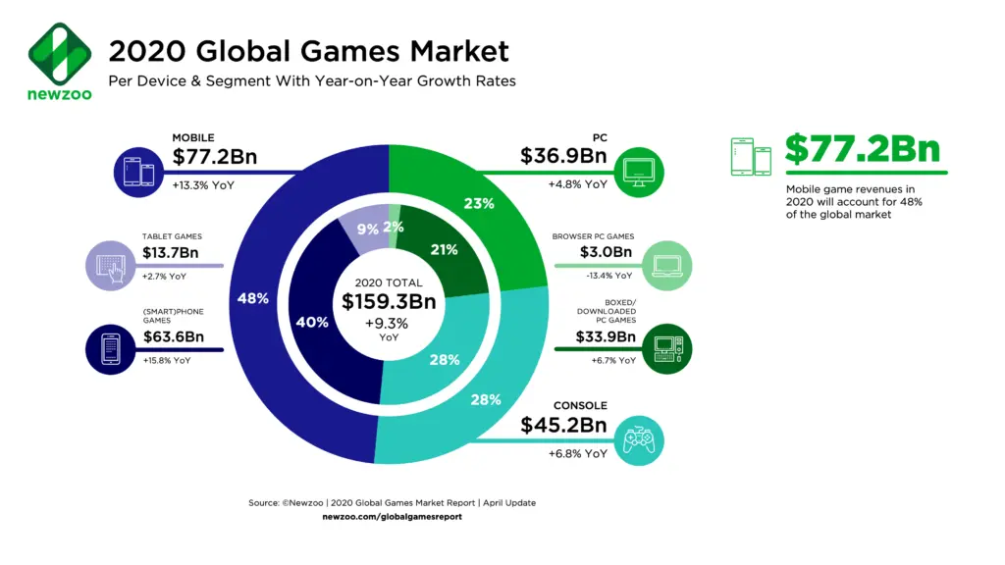

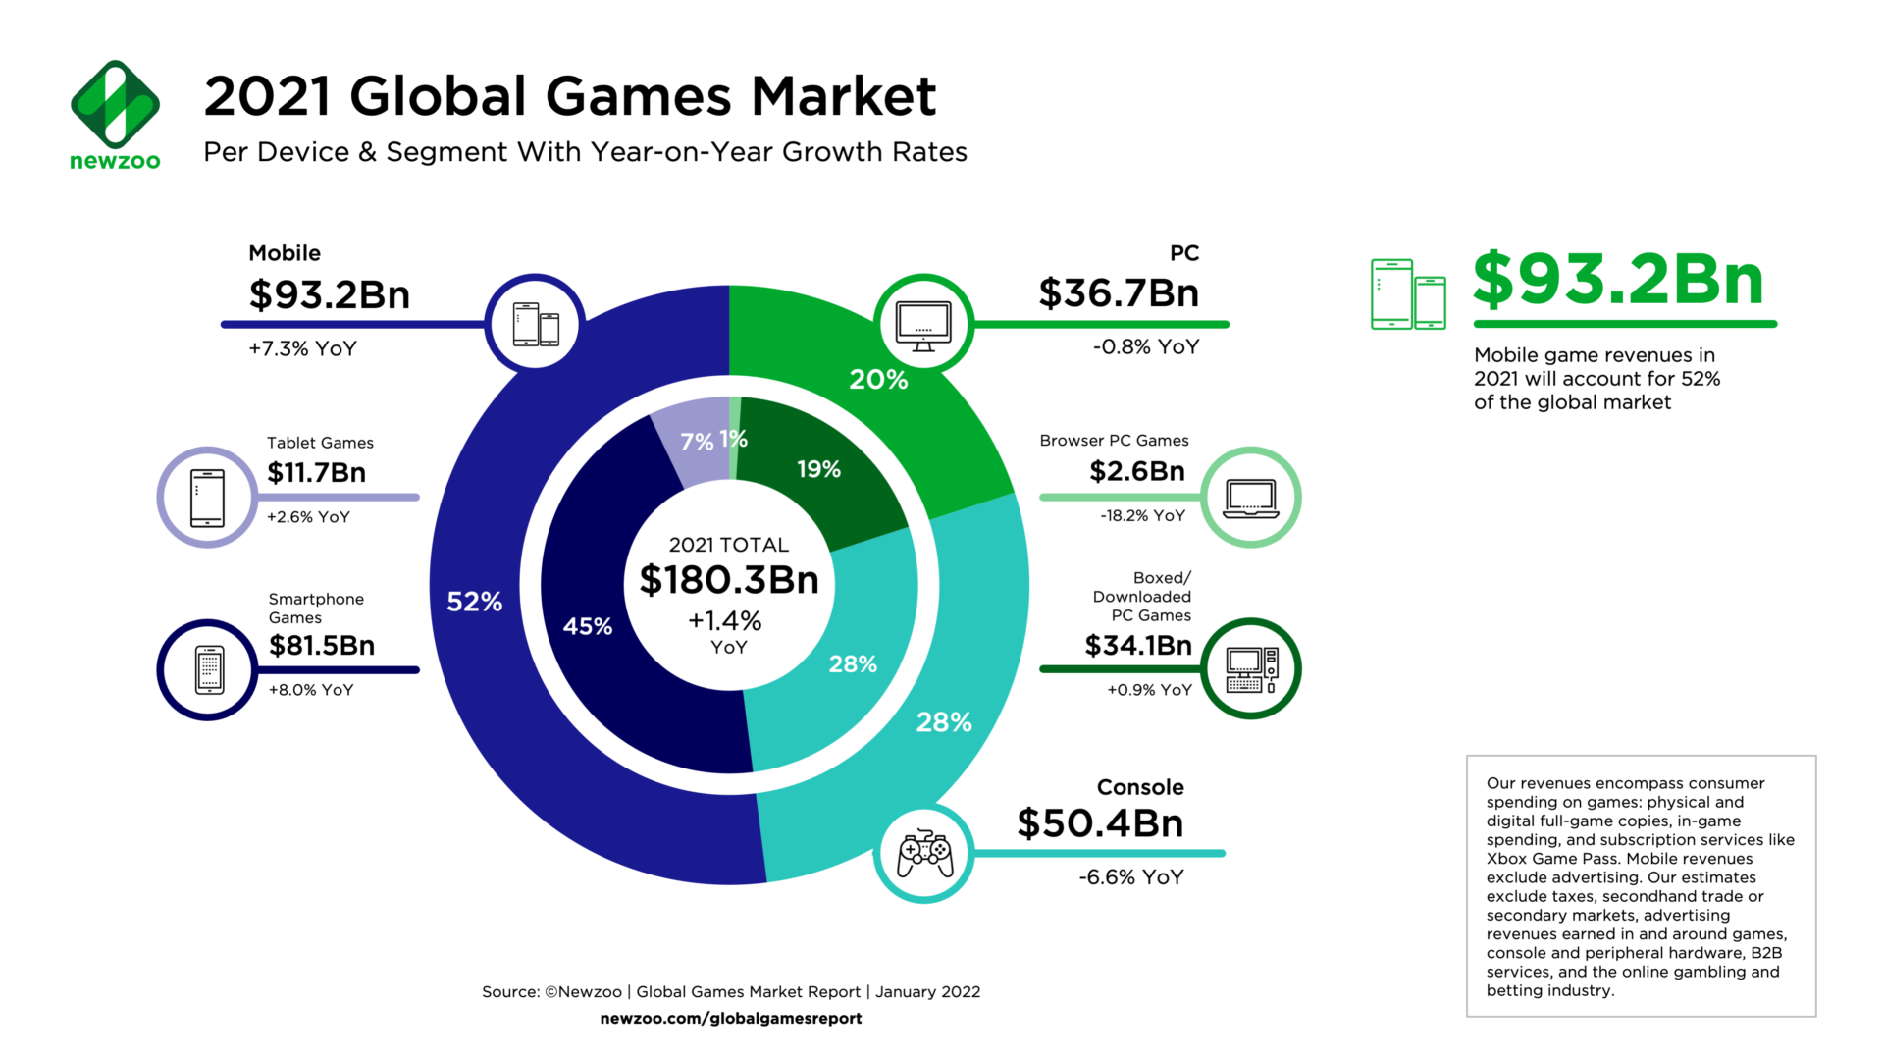

## 1.2 Problem Statement

In recent years, most of the top game e-commerce platforms have increased from simple third-party game sales to digital rights management (DRM), server hosting, video streaming and social networking services. Although the business line has been further expanded, there is still a lack of personalized recommendation of games for specific users. At the same time, game peripheral products have not received sufficient attention in most game e-commerce websites. Therefore, the market needs a game e-commerce platform that focuses on B to C games and game peripheral sales, recommends games that users are interested in through a qualified personalized recommendation system, and enables users to purchase at a certain discount.

This project is dedicated to developing a digital storefront for games and game related peripherals. The user group of this website can be roughly divided into unregistered customers, registered customers, and admin. **Since the games and peripherals sold by Gazzar are virtual chapins in the form of CDKEYs, they will not be returned if they have been sold.**

Visitors can only view the homepage, but for the majority of registered users, Gazzar provides a very complete game selling and recommendation platform based on the integration ability of many games and peripherals. Since Gazzar is essentially a collection mall, all game products from different gaming development companies will be sold in the form of CDKEYs, and users could exchange them through the games' operating platform after purchasing. In Gazzar Gaming, users can check and purchase various kinds of hot games with a certain discount. It truly serves users' one-stop shopping and solves various tedious problems from cross-game platforms. Meanwhile, Gazzar introduces a recommendation system to save users' search time and increase the exposure of games that really suit customers' preferences to deal with the problems of incomplete recommendation system in many game serving platforms. Additionally, Gazzar will set up a sweepstake and a surprise discount store based on personalized recommendations to increase sales.

At the same time, Gazzar Admin also builds a complete set of back-end features, which integrates digital sales presentation, products management and stock management to help merchants realize real-time and staged sales data display, quick replenishment and removal of products, and view various order information.

As a system involving transactions, we want to provide a platform with secure and reliable user interaction. We will carry out follow-up detailed development for the above aspects, improve the system during program development, and keep refining details during the project.

## 1.3 Competitive Analysis

### 1.3.1 Steam

<https://store.steampowered.com/>

Steam is a video game digital distribution service launched by Valve Corporation as an independent software client in September 2003 and has gradually expanded to form a web-based online and mobile digital storefront with games from third-party publishers. Today, the Steam platform is one of the world's largest comprehensive digital distribution platforms for PC games, where players can buy, download, discuss, upload and share games and software. According to Statista, in September 2021, Steam peaked at more than 26.09 million concurrent users. **(Clement, J., 2021)**

The advantage of Steam lies in the integration of its platform. Because it is combined with the purchasing, playing and community of games, users can get the most complete one-stop experience on Steam. The scoring mechanism applies to the community, not to the store. Steam does not consider the Key players, but the voice of Steam Key players is still important, and Gazzar has the potential to be its representative on this. Since it has relatively complex commercial factors, the overall performance of the recommendation system is not outstanding enough. It is difficult for the first publishers and their own event users to purchase suitable games based on their own preferences and evaluations.

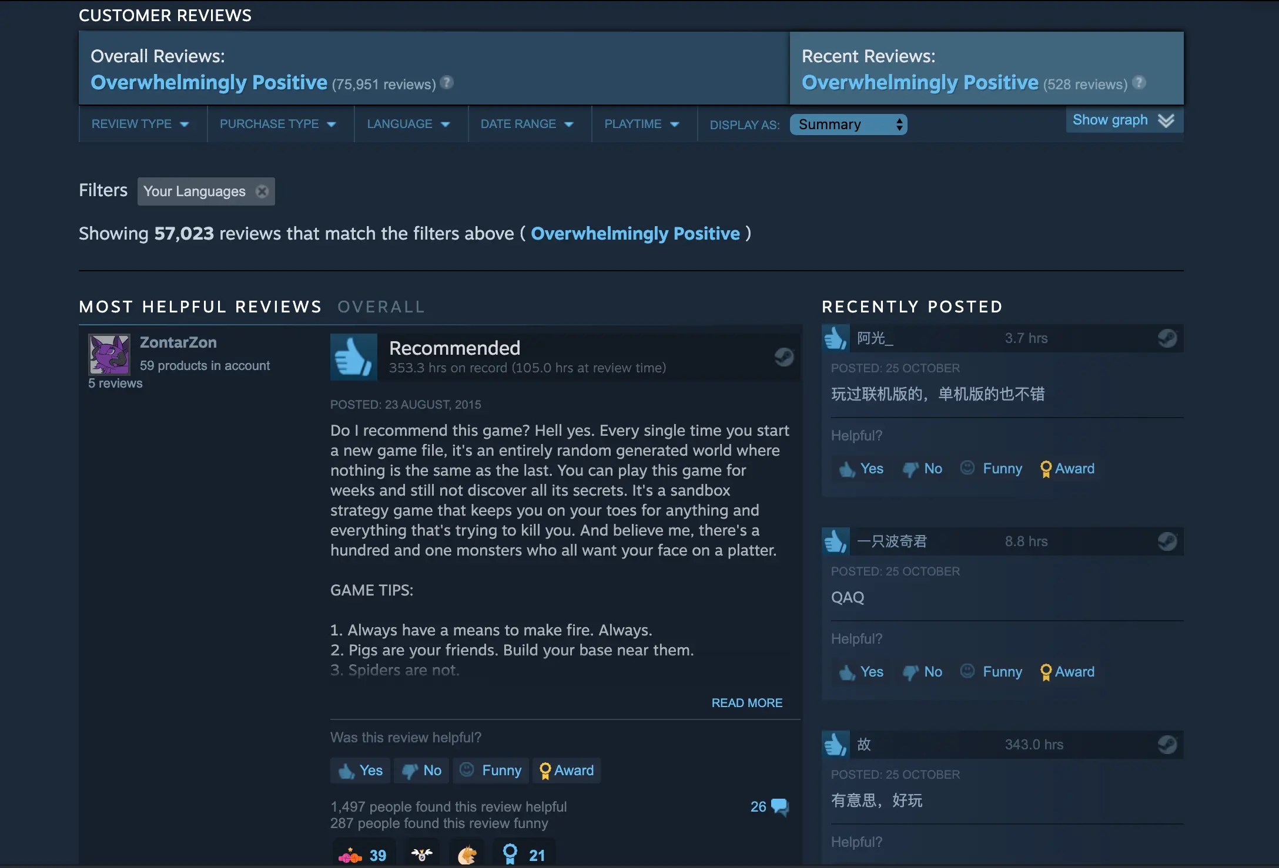

### 1.3.2 [Humble Bundle](https://www.humblebundle.com/?hmb_source=navbar)

<https://www.humblebundle.com/?hmb_source=navbar>

Humble Bundle, Inc. is a video game digital storefront that grew out of its original offering of Humble Bundles, collections of games sold at a price determined by the purchaser, with a portion of the proceeds going to charity.

The advantage of Humble Bundle is that its discount model for charity packs is a suitable option for many customers. However, its advantages also create its disadvantages: due to the imperfect recommendation system, its promotion is still carried out around the discount activities of third-party publishers, and there are no peripheral products on sale.

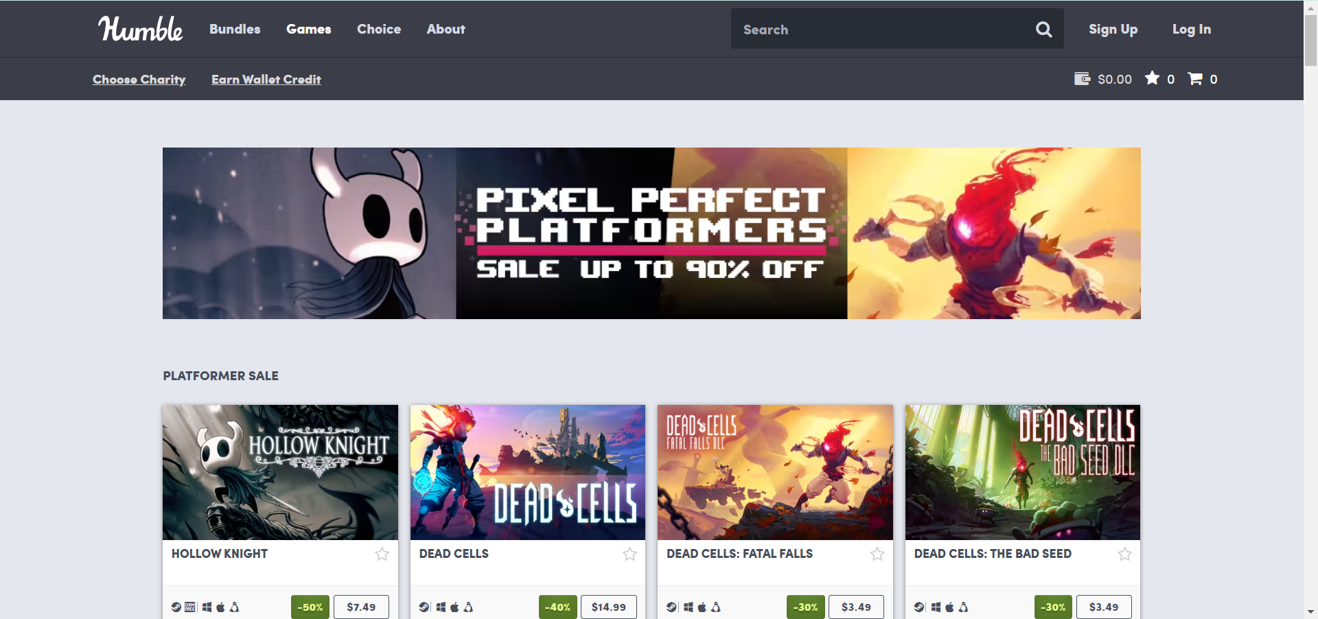

# 2. Epics and User Stories

All epics and user stories of Gazzar are given below. The epics and stories are designed based on backgrounds.

## 2.1 Epic1: Client Account

Users can view the default index page (Home Page) without logging in to their account. The following describes the differences between the functions available when a user does not Login (Logout) and when a user Login.

### 2.1.1 Register for basic information (estimated difficulty: 3/5; time estimate: 10 h)

**User story:** As a new visitor to this website, I want to use this website for further operations (visit the Business Details Page, make payment, etc.), so I need to register to become the real user.

**Acceptance criteria and Description:**

When users access the *Register Page*, the user needs to carry out two steps, account information and preference questionnaire. They need to follow the steps to enter the correct nickname, gender, age, email address, and password. Click 'Next' button to Questionnaire Page to register the new account. Details are as follows:

* Users need a nickname
* Nickname cannot be null.
* Gender
* Male / Female / Mysterious (optional)
* Age
* Must be positive number (>0)
* Users need to register via email account
* Check valid email
* The email is used only once.
* Password setting: the password setting follows the general rule:
* The password must be 8-15 characters
* The password must contain at least one character from each of the following groups: ·lower case alphabet, uppercase alphabet, numeric, special characters(@#$%^&,*)
* If the user already has an account, they can also click 'Already Have an Account? Try to Login >>' to login Page.
* When the user finishes registration, automatically jump to Questionnaire Page to select the preferences about games.

### 2.1.2 Register with interest questionnaire (estimated difficulty: 3/5; time estimate: 10 h)

**User story:** As a user, I hope the website can customize the Home Page information according to my personal preferences, so that I can quickly find the products I'm interested in when I am on the home page.

**Acceptance criteria and Description:**

When the user completes the first step of registration, the Questionnaire Page will be automatically displayed, and the page will provide all game categories ‘label and peripheral categories’ label of the website. After clicking 'Register', the Login Page will display. At this time, the user has completed all the registration of the new account. Details are as follows:

* User can skip this step by ticking none of these boxes
* All labels are optional
* The user 's Home Page after selecting the labels will push some products that users are interested in.
* If the user skips the preference selection, Home Page will be the fixed Default Home Page.

### 2.1.3 Login (estimated difficulty: 2/5; time estimate: 6 h)

**User story:** As a customer, I want to login to my account when I revisit the website, so that I can use the website features.

**Acceptance criteria and Description:**

After the user registered, click 'Login' on Home Page or do any operation on the Home Page, the page will turn to Login Page. The user needs to implement the matched Email and Password. Then the system will verify whether it is correct. If it is correct, the user can log in. Details are as follows:

* Email
* Existing and Registered
* Incorrect email
* Password
* Incorrect password
* User can choose 'Forget Password' to Password Retrieval Page and retrieve password.
* User can choose 'Register for Free' to Register Page and register a new account.
* After the user login successfully, the user will be redirected to the Home Page with a registered identity.
* The user will remain in their identity by the cookies

### 2.1.4 Forget password (estimated difficulty: 3/5; time estimate: 10 h)

**User story:** As a user of this website, I want to retrieve password by email, so that I can solve the problem of account login.

**Acceptance criteria and Description:**

If a user forgets the account password on the login page, click ‘Forget Password' to switch to the Password Retrieval Page. The user needs to type correct account email. The system automatically sends the randomly generated new password to the account email, and the user can reset the password in the Profile Page later. Details are as follows:

* Valid email
* New password will generate randomly
* When the user clicks 'Send', automatically jump back to the Login Page

### 2.1.5 Logout (estimated difficulty: 1/5; time estimate: 3 h)

**User story:** As a user of this website, I want to log out my account after finishing shopping, so that my account profile will not be leaked.

**Acceptance criteria and Description:**

When users visit thePage with Logout Icon, they can click the 'Logout' button to log out of the current account, and automatically jump back to the default Home Page.

* Default Home Page will display fixed content (without user's customized recommendation)

## 2.2 Epic2: Customer Profile

User can view and edit the personal profile, reset password and change payment options in the customer profile.

### 2.2.1 Reset Password (estimated difficulty: 2/5; time estimate: 6 h)

**User story:** As a user, I hope I can reset my password, so that I can maintain the security of my account.

**Acceptance criteria and Description:**

When the user accesses the Profile Page from the Page with Profile Icon, they can reset the new password by clicking 'Change My Password'. The user needs to enter a new password and click 'Done' to finish setting.

* New password also needs to obey password rules

### 2.2.2 View Profile (estimated difficulty: 3/5; time estimate: 10 h)

**User story:** As a user, I want to have my own profile via a specific page, therefore I can check my personal information and change the information in my account.

**Acceptance criteria and Description:**

After the user login in, the user can view the Profile Page with Profile Icon. If the user wants to update the profile. The user can click 'EDIT' button. But the user cannot edit the balance. Details are as follows:

* User Avatar (four status)
* Visitor status
* Male status (After registration)
* Female status (After registration)
* Mysterious status (After registration)
* Nickname
* Editable
* Cannot be null
* Email cannot be changed in the development phase

### 2.2.3 Payment Options (estimated difficulty: 2/5; time estimate: 6 h)

**User story:** As a user, I want to record my payment card information, therefore I can use my different recorded payment option to pay the bill.

**Acceptance criteria and Description:**

After the user login in, the user can view the Profile Page with Profile Icon. If the user wants to update the payment details (including adding and deleting), user could click '+' and ‘delete’ button.

* My Payment Option
* The default is empty
* Users need to add manually
* User could save multiple payment options.
* To modify the payment option, the user needs to delete the original and add a new one
* The payment option needs to provide Card type, Card number, Name on card and Expiration date

## 2.3 Epic3: Browse website

User can view the home page and view the product details when the user purchases the games.

### 2.3.1 Home Page (estimated difficulty: 4/5; time estimate: 15 h)

**User story:** As a new visitor to this website, I hope the Home Page has diversified contents, so that it can attract the interest of visitors.

**Acceptance criteria and Description:**

Users can access the Home Page in login status and visitor status, but customized recommendations will be displayed after logging in, otherwise it will be the default page. Home page will provide the following functions:

* Search box
* My profile
* Cart management
* Order management
* Rolling recommendations and activities
* All Products
* Games and Peripherals
* Product will display the corresponding image, rate and name
* All displayed components are clickable and will visit the designated page

### 2.3.2 Product Details Page (estimated difficulty: 4/5; time estimate: 15 h)

**User story:** As a customer, I want to see more details about the product, so that I can know more about the product.

**Acceptance criteria and Description:**

Users can access Product Details Page through Home Page, Search Results Page and Surprise Store Page. The Product Details Page mainly introduces the basic information of the specific product. Details are as follows:

* Images
* The maximum quantity is 5
* The first image is the product cover
* Product Name
* Price
* 2 decimals
* For discounted products visited by the Surprise Store Page, the original price, discounted price and discount will be displayed in the price area
* Quantity
* It can be edited through '-', '+' and input textbox
* Quantity cannot exceed Stock
* Product Type
* Display all types, separated by ','
* Stock
* Add to Cart (Button)
* Buy Now (Button)
* Overall Rate
* Range: 0~5
* 1 decimal
* The default Overall Rating is 5.0
* Product Details (Description)
* Comment
* The existing comments are from users that have already purchased this product
* Overall Rate and Score of each purchased user (starlike layout)
* Latest priority
* Logout / Cart / Profile / Search box will visit the designated page

## 2.4 Epic4: Search website

Users can search products by some keywords and filter searching results by category. Users can also sort searching results.

### 2.4.1 Sort Filter (estimated difficulty: 4/5; time estimate: 15 h)

**User story:** As a user of this website, I want to pick items by category, so that my shopping with purpose can be more efficient.

**Acceptance criteria and Description:**

Users can access the Search Result Page through the Funnel Icon on Home Page or Search box. And users can use combined sorting to search the products of the specified type (For example, choose an ’RPG‘ and ‘FPS' at the same time). Details are as follows:

* Products names are in alphabetical order A-Z
* Price
* Ascending order
* Descending order
* The rating defaults from high to low
* By ticking the box before each type to sort
* Combined sort is allowed
* Search results will show all qualified product blocks
* Click product blocks (Search Results Area) can jump to Corresponding Product Detail Page

### 2.4.2 Search box (estimated difficulty: 3/5; time estimate: 10 h)

**User story:** As a consumer with clear goals, I hope the web page has a search box, so that I can quickly find the product I want to buy.

**Acceptance criteria and Description:**

Users can use the search function in the Page containing search box, search all products of the website by entering characters, and jump to the Search Result Page. If no search result is found, the search result area is empty, otherwise, the matching product information block is displayed. Details are as follows:

* The system retrieves the contents entered in the search box according to the product name, type and description (Product details)
* When retrieving the content entered in search box, it is not considered the upper or lower case
* Click product blocks (Search Results Area) can jump to Corresponding Product Detail Page

## 2.5 Epic5: Order

User can view the order details including CDKEY, order number and so on. And in the order detail page users can also rate and comment. And users can also view the history orders.

### 2.5.1 Order Details page (estimated difficulty: 3/5; time estimate: 10 h)

**User story:** As a consumer, I want to check some further information after clicking the specific order, so that I can know more details of what I have bought.

**Acceptance criteria and Description:**

Users can click the order in the history order list to access the specified order details page. The details page will contain the following information：

* CDKEY
* All games sold on this website are provided in the form of CDKEY
* The peripheral product's CDKEY area is displayed as ‘-’ form
* Length of CDKEY is 15, Separate every 5 characters with '-'
* Characters can only be numbers and capital letters
* Order number
* Length of order number is 20
* Order number is clickable, if the user wants to check the information of one entire order with multiple kinds of products.
* Trading hours
* Traded Product Name, Quantity and Unit Price
* Actual transaction price
* Unit Price * Quantity * Discount (if exist)
* Discount
* '-' for no discount
* My Rate (Star layout) and Comment, click 'Finish' to update

### 2.5.2 History Order Page (estimated difficulty: 3/5; time estimate: 10 h)

**User story:** As a consumer, I want to be able to see all the orders I have purchased, so that I can browse my consumption history.

**Acceptance criteria and Description:**

Users can access their own History Order Page through the Home Page. If the user has no order history, a blank page will be displayed. If yes, the order list is displayed. In order to facilitate users' view, the system displays the order information in units of products. Details are as follows:

* Products purchased from the same order will generate the same order number
* The brief details of the order (blocks) will show:
* Product cover, product name, product details (part), quantity and Price
* The listed price represents the actual transaction unit price of the item, i.e. Unit Price * Discount (if exits)
* Click blocks to check more details (jump to Order Details Page)
* If Price is '$0', It means that the product is obtained free of charge through the user lottery activity
* The product is obtained free of charge through the user lottery activity will automatically generate order block and display it in History Order Page
* Only 5 product orders (block) are displayed at a time (latest), over blocks are displayed by page control
* 'Guess you Like...' Area randomly displayed the three hottest products

### 2.5.3 Rate (estimated difficulty: 2/5; time estimate: 6 h)

**User story:** As a user of this website, I want to rate a specific product after I buy, so that others can pick product according to overall rate.

**Acceptance criteria and Description:**

Users can evaluate rate for the specified products in the Order Details Page. Details are as follows:

* Rating is non-essential
* Evaluation scores is Star layout
* Only supported full star, means 1 grade
* Range: 0 ~ 5
* The overall rate of specified product is calculated as an average
* Click 'Finish' means uploading the rate
* After the rate is uploaded, the overall rate of the specified product will be automatically updated
* Can only rate once, cannot edit it again

### 2.5.4 Comment (estimated difficulty: 2/5; time estimate: 6 h)

**User story:** As a user of this website, I want to comment on a specific product after I buy it, so that others can pick product according to comments.

**Acceptance criteria and Description:**

Users can evaluate one comment for the specified products in the Order Details Page. Details are as follows:

* Comment is non-essential
* The comment max length of characters is 500
* Comment does not support expressions and pictures
* Click 'Finish' means uploading the comment
* After the comment is uploaded, the comments of the specified product will be automatically updated
* Can only comment once, cannot edit it again

## 2.6 Epic6: Cart

User could save multiple products in their shopping cart, meanwhile, user could add and delete products in the shopping cart.

### 2.6.1 View Cart Products (estimated difficulty: 3/5; time estimate: 10 h)

**User story:** As a customer, I need to check a list of all the products in my cart, so I can make purchases when I want.

**Acceptance criteria and Description:**

The user can access the shopping Cart Page on any page containing the shopping Cart Icon. If the user has not added product to the shopping cart, the empty page will be displayed. On the contrary, the products of the shopping cart will be displayed. Details are as follows:

* The brief details of the product (blocks)
* Product cover, product name, product details (part), quantity and Price
* The listed price represents the actual transaction unit price of the item, i.e. Unit Price * Discount (if exits)
* Click blocks to check more details (jump to Order Details Page)
* Show 10 blocks once, others are displayed by page control
* Hover over the end of the block to delete the product
* Batch purchases can be made by ticking boxes
* ‘Check out' will jump to Payment Page
* The poster advertising area will publicize the website's lucky draw in the form of picture

### 2.6.2 Add Item (estimated difficulty: 2/5; time estimate: 6 h)

**User story:** As a customer, I need to add some products to my cart, so that I can buy them in the cart later.

**Acceptance criteria and Description:**

The user can add products to the Cart by 'Add to Cart' button when viewing Product Detail Page. Details are as follows:

* User can use the functions on the Product Detail Page to edit the quantity before adding
* The total items in Cart cannot exceed 50.

### 2.6.3 Delete Item (estimated difficulty: 2/5; time estimate: 6 h)

**User story:** As a customer, I need to discard some products from my cart list, so that I can delete the item that I do not want to buy.

**Acceptance criteria and Description:**

The user can delete specific product on Cart Page by hovering over the end of the block.

## 2.7 Epic7: Payment

Users can pay for the products what they want to buy. The page can generate bill information for this payment. Users can choose how to pay online.

### 2.7.1 Checkout (estimated difficulty: 3/5; time estimate: 10 h)

**User story:** As a user of this website, I want to have Payment page after I order, so that I can confirm the total amount and payment method of the order.

**Acceptance criteria and Description:**

When the user clicks ‘Buy now’ on the Product Details Page and ‘Checkout’ on the shopping Cart Page, the Payment Page of the order will be automatically generated. Details are as follows:

* Place My Order
* The brief details of the order (blocks) — Refer to 2.4 (2) for details
* The product orders obtained from the lottery activity will not produce the Payment Page
* List form, show 2 blocks once, others are displayed by page control
* Payment Option
* If my profile has been set, it will be displayed automatically
* If not, add and edit manually — Refer to 2.2 (3) for details
* Payment Information
* Original Price
* Total Discount, '-' for no discount
* Actual Transaction, Original Price * Total Discount (if exist)
* If the user clicks the 'Place Your Order in AUD' will jump to Bank Payment Page.

## 2.8 Epic8: Recommendation

The gaming ecommerce Gazzar requires a mature recommendation system, to recommend products according to the user's profile,

### 2.8.1 Recommendation (estimated difficulty: 5/5; time estimate: 20 h)

**User story:** As a user of this website, I want the website to recommend something that matches my preference, so that I can buy products that fit me better.

**Acceptance criteria and Description:**

* The items shown on the home page are already sorted by the recommendation algorithms.
* The evaluation conditions of the recommend system come from multiple dimensions such as the user's personal information, preferences, browsing records, hottest products and purchase records etc.

### 2.8.2 Recommendation in carousel & other place (estimated difficulty: 5/5; time estimate: 20 h)

**User story:** As a user of this website, I want the website to recommend something that matches my preference in the carousel and other areas of the pages, so I can be reminded to check something from time to time.

**Acceptance criteria and Description:**

* The items shown on the home page are already sorted by the recommendation algorithms.
* The information of the recommendation may display in the carousel and other areas of the pages, such as the history order.
* The evaluation conditions of the recommend system come from multiple dimensions such as the user's personal information, preferences, browsing records, hottest products, and purchase records etc.

## 2.9 Epic9: Surprise Store (Novel feature)

User could access a unique surprise store. In the surprise store, users can purchase games at special discounts. Besides, all the games in each users' store are customized.

### 2.9.1 Surprise Store (estimated difficulty: 5/5; time estimate: 20 h)

**User story:** As a user of this website, I want to have a limited time offer in a surprise store, so that I can pick cheaper items for this activity.

**Acceptance criteria and Description:**

Registered users can access their own Surprise Store Page through the rolling recommendations/ activities module of Home Page. The Surprise Store Page mainly provides user specific discounts and personalized recommended products. And the user can click on each item to check further details. Details are as follows:

* Weekly activity
* All users have the same discount
* Discounts may vary weekly
* Definition of personalized recommended products
* Quantity limit — 12
* The Recommendation of Surprise Store is different from the normal recommend algorithm where the customers look through the Home Page and search results.
* Range: Recommended products (hottest) + Most interested products (user-based)
* Recommended products (hottest) refer to the most popular and best-selling products at the sales-end according to the sales statistics.
* Most interested products (user-based) refer to the products that users often search, browse and the products they pay attention to in the shopping cart

## 2.10 Epic10: Personalized Lottery (Novel feature)

In Lottery Page user can get opportunities to take prize wheel after the user purchases.

### 2.10.1 Personalized Lottery (estimated difficulty: 5/5; time estimate: 20 h)

**User story:** As a customer of the website, I hope the website can launch a lucky draw. So that I can have the opportunity to get my ideal products for free.

**Acceptance criteria and Description:**

* All users have one chance of winning a lottery after each payment.
* The lottery should be taken immediately after each successful payment.
* The prize pool of the lottery is composed of current popular products and personalized recommended products (only including games and no peripherals)
* Customers have a certain possible chance of not being able to win any prizes.
* After the user wins the prize, the prize is displayed on the order page with the price of $0.
* When the customer wins the lottery, the customer is able to check out the order details based on the pop-up notification.

## 2.11 Epic11: Admin Account

Admins could realize the administers authorisation management including normal admins log-in and log-out, admins account registration and deleting.

### 2.11.1 Login (estimated difficulty: 2/5; time estimate: 6 h)

**User story:** As an administrator, I want the website to log in to my working account, so that every administrator can manage the website.

**Acceptance criteria and Description:**

When the administrator accesses the sales side, it needs to log in. The administrator needs to enter the correct email and password according to administrator ‘s own working account in order to log in successfully. Details are as follows:

* Incorrect email
* Incorrect password
* After the user login successfully, the user will be redirected to the sales side Home Page
* There is a unique boss account on the default website of the system
* Super-admin, account email: 1807655499@qq.com, account password: Boss#123
* The addition and authorization method of admin account requires the boss account (Super-admin) to be operated in the admin management interface after logging in — Refer to 2.7 (3) for details

### 2.11.2 Logout (estimated difficulty: 1/5; time estimate: 3 h)

**User story:** As an administrator, I hope I can log out of the account, so that my account profile will not be leaked.

**Acceptance criteria and Description:**

The administrator can exit the account by clicking any page containing 'Logout' on the sales side. Details are as follows:

* When the administrator exits the login, the page will automatically jump back to the sales side Login Page

### 2.11.3 Admin management (estimated difficulty: 3/5; time estimate: 10 h)

**User story:** As an admin, I want to see other admins in the system, so that I can reach them and follow things they have been done recently.

**Acceptance criteria and Description:**

After logging in, the administrator can access the Admin Management Page through the management option on the left of the page. In order to protect the authority security of the website and prevent data leakage, the website has a Super-admin (boss account) by default. All operations of adding and deleting administrators can only be completed by super admin account. Details are as follows:

* Super-admin account
* Can register and authorize a new administrator account — Refer to 2.7 (4)
* default ID No. 1, cannot be removed.
* Can delete other administrator's working account
* Can browse all administrator accounts' information (ID, email, password)
* Administrator account
* Can only browse all administrator accounts' work email and ID (except the current account)
* The current account can browse the account's information
* Show 5 account information once, others are displayed by page control
* Management Options / Logout will visit the designated page

### 2.11.4 Register and Delete Admin (estimated difficulty: 2/5; time estimate: 6 h)

**User story:** As an Super-admin, I want to have a method of admin authority management, so that I can add a new admin account for my colleagues, and delete useless admin accounts.

**Acceptance criteria and Description:**

After the Super-admin successfully logs in, by clicking the admin management option in the left list to access it, and after inputting the new admin account work email details in the text box, click 'Register new admin' to register a new admin account. Additionally, click 'delete' button on the operation list. Details are as follows:

* Only Super-admin account
* Admin needs to register via email
* Password setting: the password setting follows the general rule:
* The password must be 8-15 characters
* The password must contain at least one character from each of the following groups: ·lower case alphabet, uppercase alphabet, numeric, special characters(@#$%^&,*)

## 2.12 Epic12: Sales information

The page will show admin the overall transactions and overall users’ information.

### 2.12.1 View the Overall Sales (estimated difficulty: 3/5; time estimate: 10 h)

**User story:** As an admin, I hope I can see the sales summary of website products, so that I can adjust products and formulate strategies in time according to the sales volume.

**Acceptance criteria and Description:**

After logging in, the administrator can access the View Sales Page through the management option on the left of the page by clicking 'Overview'. Details are as follows:

* Gross Merchandise Volume (GMV)
* Monthly Gross Merchandise Volume
* Average Transaction Value
* Best Seller
* Total registered users
* Management Options / Logout will visit the designated page

### 2.12.2 Order Information (estimated difficulty: 3/5; time estimate: 10 h)

**User story:** As an administrator, I want to manage all the transaction orders on the website, so that I can save the order vouchers and details.

**Acceptance criteria and Description:**

After logging in, the administrator can access the Order Management Page through the management option on the left of the page. The interface will display all order vouchers and order details. Details are as follows:

* Can search the specified order by order number
* In order to facilitate admins' view, the system displays the order information in units of products
* Products purchased from the same order will hold the same order number
* Order details include:
* Order number
* Product Name
* Quantity
* Discount
* Trading hours
* Actual transaction price
* Show 5 order vouchers and details once, others are displayed by page control
* Management Options / Logout will visit the designated page

## 2.13 Epic13: Products Management

The admin can manage the product including adding and deleting products. In addition, admins could edit specific information of each product including stock management. Meanwhile, admins also could check out the specific information of each product (including rate and comment) by searching and its classification ability.

### 2.13.1 View Product (estimated difficulty: 2/5; time estimate: 6 h)

**User story:** As an admin, I want to view products in my shop, so that I can find what products I am selling.

**Acceptance criteria and Description:**

After logging in, the administrator can access the Games / Peripherals Management Page through the management option on the left of the page. The interface will display all products, product information and operations. Details are as follows:

* Can search the specified product
* Can classify by State / Type
* Add new Product
* Block details
* Product ID
* Product name
* Product Type
* Rate
* State
* Operation
* Edit / Delete
* Last Modified by
* Stock
* Show 5 product blocks, others are displayed by page control
* Management Options / Logout will visit the designated page

### 2.13.2 Add Product (estimated difficulty: 2/5; time estimate: 6 h)

**User story:** As an admin, I want to add a new product to my system, so that I can sell a new product on this website.

**Acceptance criteria and Description:**

After the administrator successfully logs in, they can click the management option in the left list to access it and click 'Add new product' to jump to the new interface to add a new product. The details of adding products are as follows:

* Images
* Images at least 1 and at most 5
* Product Name
* Product Type
* Description
* Unit Price (2 decimal)
* State
* On Sale/ On Promotion
* Stock
* Must be integer
* Product ID automatic generation
* Management Options / Logout will visit the designated page

### 2.13.3 Edit Product (estimated difficulty: 2/5; time estimate: 6 h)

**User story:** As an admin, I want to edit detail of products in my shop, so that I can change products' characteristics. (Name, description, picture, type, etc)

**Acceptance criteria and Description:**

After the administrator successfully logs in, they can click the management option in the left list to access it and click 'Edit' to jump to the new interface to edit a new product. Details are as follows:

* All properties of the product can be changed
* Click 'Submit' to update product information and jump to Last Page
* Management Options / Logout will visit the designated page

### 2.13.4 Replenishment (estimated difficulty: 3/5; time estimate: 10 h)

**User story:** As an administrator, I want the system to manage the product stock of the website including the sold-out products, so that I can replenish them in time.

**Acceptance criteria and Description:**

After logging in, the administrator can access the Game Management Page. By default, the system will automatically retrieve the stock after each transaction. When the stock of the product is 0 (sold out), it is will be replenished by the system.

### 2.13.5 Remove Product (estimated difficulty: 1/5; time estimate: 3 h)

**User story:** As an admin, I want to delete products in my shop, so that I can withdraw some products from sale.

**Acceptance criteria and Description:**

After the administrator successfully logs in, they can click the management option in the left list to access product management and click 'Delete' to remove this product automatically.

# 3.Sprint

## 3.1 First Sprint

|  |  |  |  |
| --- | --- | --- | --- |
| Sprint | Date | Jira Objective | Jira Backlog ID |
| **1** | Start Date: 2022/3/07  Due Date: 2022/3/17 | For the customer, users can register, login and log out. If users forget password, they can receive a new password to login. Users can also view their profile and modify the password.  For the admins, users can register, login and logout, and try to build the hierarchy between admins.  Moreover, the frontend will try to develop all the index pages in the prototype design. | TDTS-37 TDTS-3  TDTS-4 TDTS-5  TDTS-6 TDTS-7  TDTS-8 TDTS-26  TDTS-27 TDTS-29 |

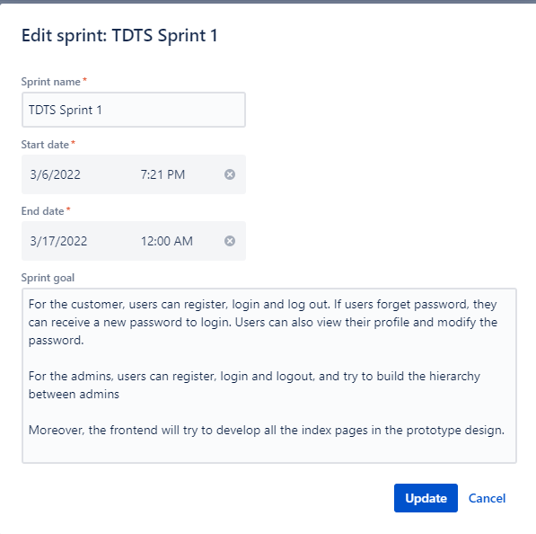Figure 3.1.1 as an example shows the sprint goal, start date, end date for each sprint.

Figure 3.1.1

### 3.1.1 First Sprint Backlog

Figure 3.1.1.1 shows all user stories for sprint 1.

Figure 3.1.1.1

Figure 3.1.1.2 shows the task board for sprint 1. Each board represents an epic.

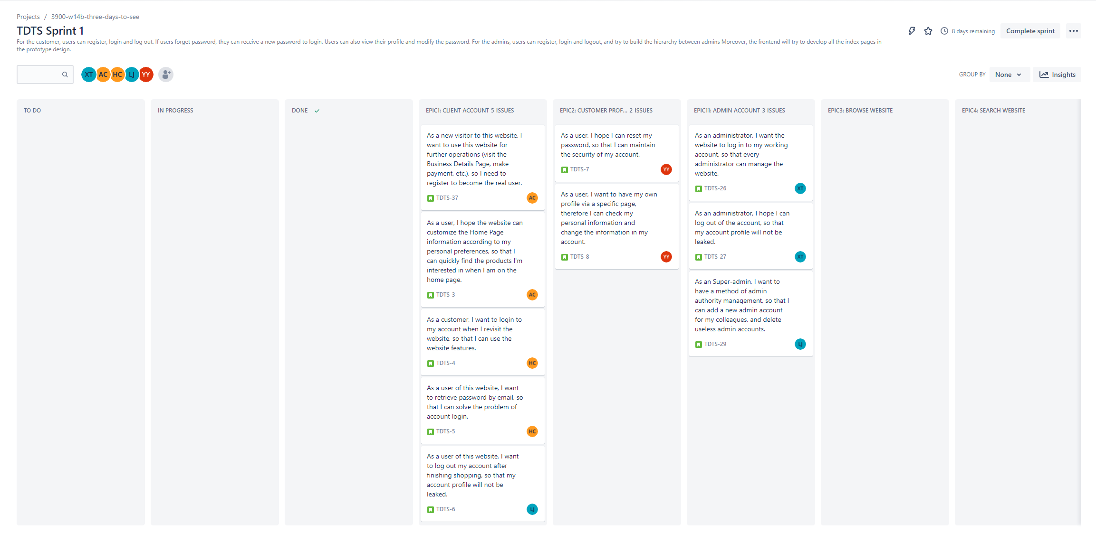

Figure 3.1.1.2

Figure 3.1.1.3 as an example shows the description and Assignee for each user story.

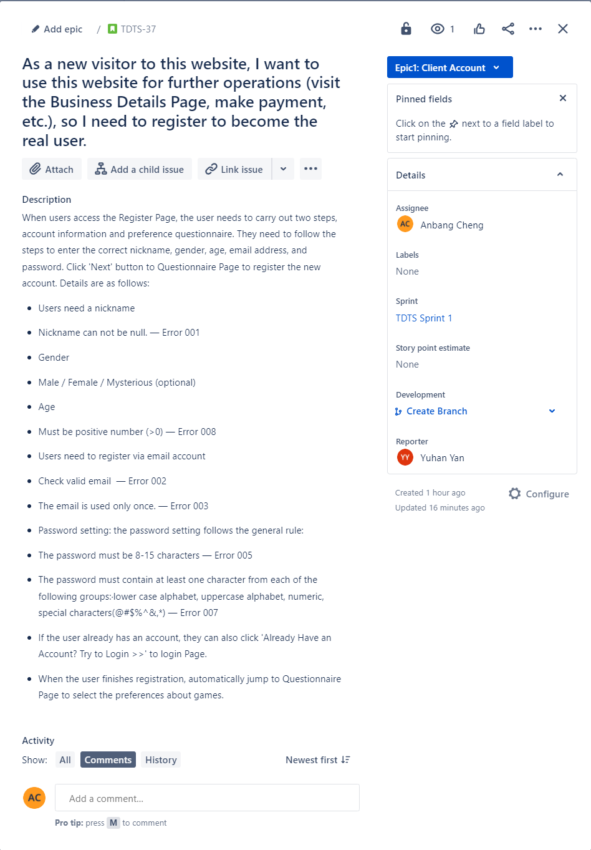

Figure 3.1.1.3

## 3.2 Second Sprint

|  |  |  |  |
| --- | --- | --- | --- |
| Sprint | Date | Jira Objective | Jira Backlog ID |
| **2** | Start Date: 2022/3/18  Due Date: 2022/4/07 | For the customer, they can add payment options, browse the website, and cart page. Besides, the user will be able to operate the cart, including view cat products, add & delete item etc. Users can pay by different methods. The users can search the products by sorting and filtering. Users can buy games that are cheap on the Surprising Store Page.  For admins, they will be able to use the system for most of the operations, including games/peripherals management such as adding, editing and removing | TDTS-9  TDTS-10  TDTS-11  TDTS-12  TDTS-13  TDTS-18  TDTS-19  TDTS-20  TDTS-21  TDTS-24  TDTS-28  TDTS-32  TDTS-33  TDTS-34  TDTS-35  TDTS-36 |

### 3.2.1 Second Sprint Backlog

Figure 3.2.1 shows all user stories for sprint 2.

Figure 3.2.1

## 3.3 Third Sprint

|  |  |  |  |
| --- | --- | --- | --- |
| Sprint | Date | Jira Objective | Jira Backlog ID |
| **3** | Start Date: 2022/4/07  Due Date: 2022/4/21 | For the customers, the users can view the order details page and view the history order so that the users will rate and comment form the order details page. The users can buy what they like according to the recommendation system. And after users make a purchase, they will be able to take prize wheel. | TDTS-14 TDTS-15  TDTS-16 TDTS-17  TDTS-22 TDTS-23  TDTS-25 TDTS-30  TDTS-31 |

### 3.3.1 Third Sprint Backlog

Figure 3.3.1 shows all user stories for sprint 3.

Figure 3.3.1

## 3.4 Backlog Total

Figure 3.4.1 and Figure 3.4.2 are showing the Total User Stories.

Figure 3.4.1

Figure 3.4.2

# 4. Technical depth, scale, report formatting

## 4.1 Interface and flow diagrams

Figure 4.1.1 is showing the flow of customer(user) operation.

Figure 4.1.2 is showing the flow of seller(admin) operation.

Figure 4.1

## Interface Prototype

The prototype in the proposal is designed as a low-fidelity prototype, and the final output may be slightly different.

### 4.2.1Register Pages

The Register Pages are divided into 2 sections.

The first one is general information about the customer . The customers need to fill in their name, gender, age, email, password, and click the 'Next' button to jump to the second step.

Step 2 is to invite customers to choose what type of game and peripherals they are interested in. Users can tick the box to choose the specific type of product, or they can just skip it by clicking the 'Register'. After clicking the 'Register' button, the user will jump to the Home Page with a registered identity.

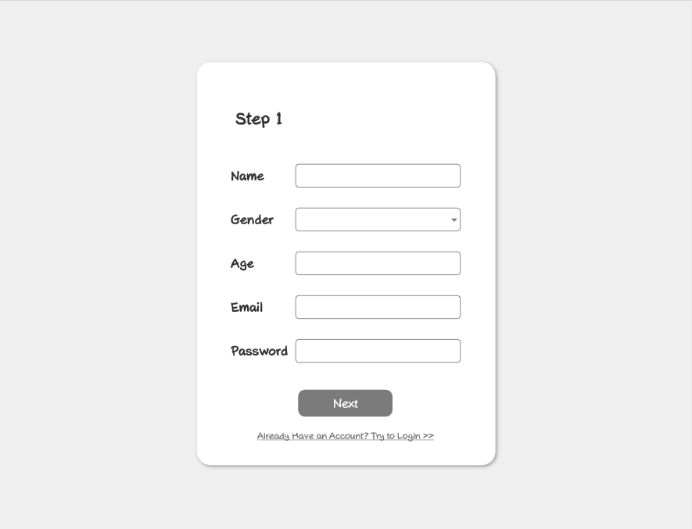

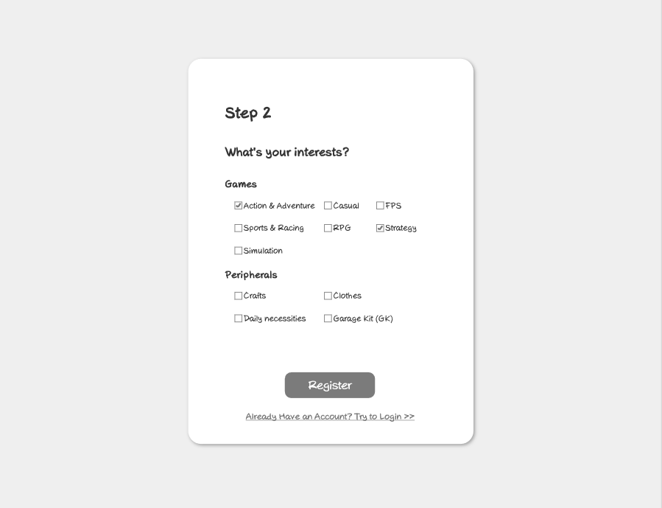

### 4.2.2 Login Page

Login page asks customers to fill Email and password that they registered, then click Login, so that customers can succeed to login main page. If customers forget their password, they can click ‘Forget your password?’ to jump to reset password page. If visitors are not registered, they can click ‘Register for Free’ to jump to register page.

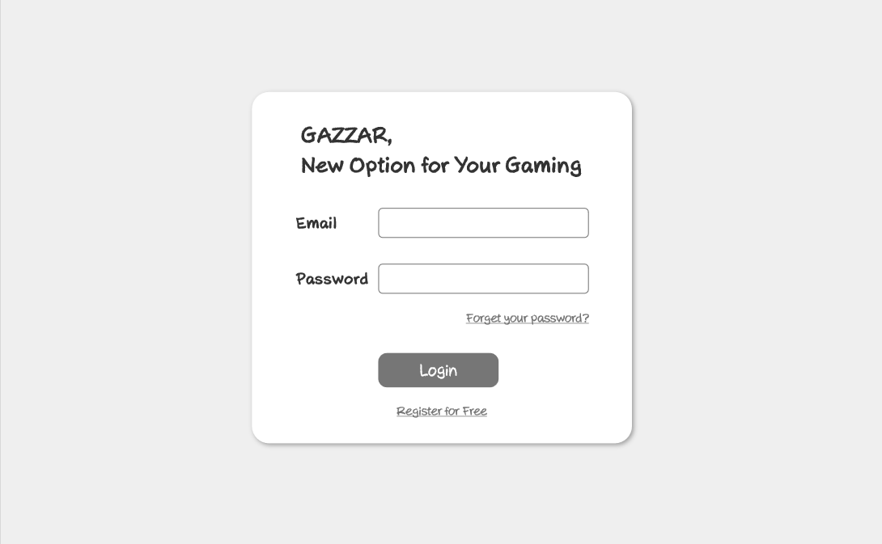

### Forget Password Page

If a user forgets the account password on the login page, click ‘Forget Password' to switch to the Password Retrieval Page. The user needs to type correct account email. The system automatically sends the randomly generated new password to the account email, and the user can reset the password in the Profile Page later.

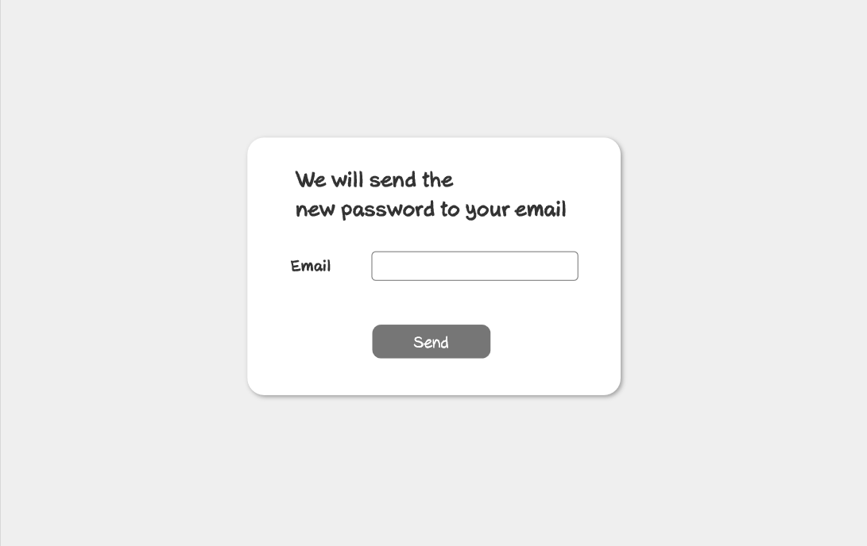

### 4.2.4 Home Page

Users can access the Home Page in login status and visitor status, but customized recommendations will be displayed after logging in, otherwise it will be the default page. Search box provides users to search items. The number below the ‘Cart’ will show the number of items. The number below the ‘Order’ will show the number of finished orders. If users click the ‘order’, users will jump to the order management page. If users click the cart icon, users will jump to the cart management page. If users click the people icon, users will jump to the profile page. User can click Logout icon to logout and jump to login page. If users click ‘Games’ button, it will show recommended game products below. If users click ‘Peripherals’ button, it will show peripherals below. Users can click games or peripherals picture to jump to this game or peripheral detail page. Each product will show its name, price and rate. The carousel on the left scrolls displays discount stores, sweepstakes, and popular products. Clicking on the corresponding image will jump to the relevant page.

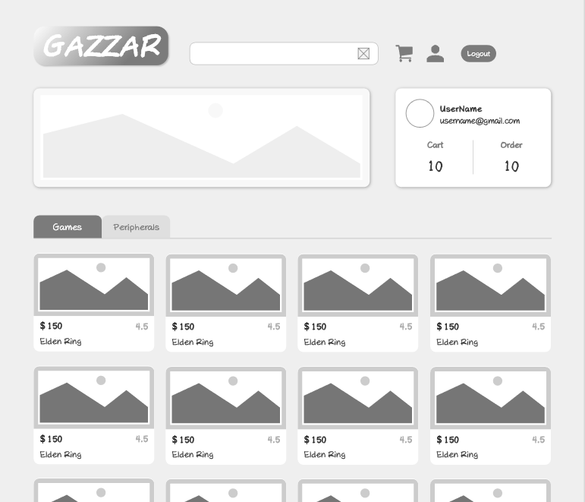

### 4.2.5 User Profile Page

User can change nickname, email and picture by clicking pencil icon. If users click Change My Password button, the system will provide users a window to fill a new password. User can click "+’ icon to add a new payment option. After users click the "+" icon, the system will provide users a window to fill with card information.

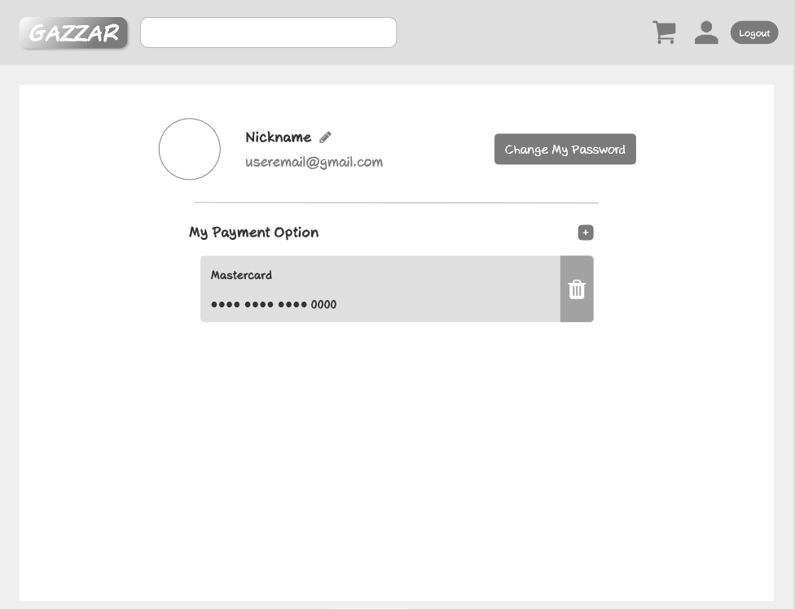

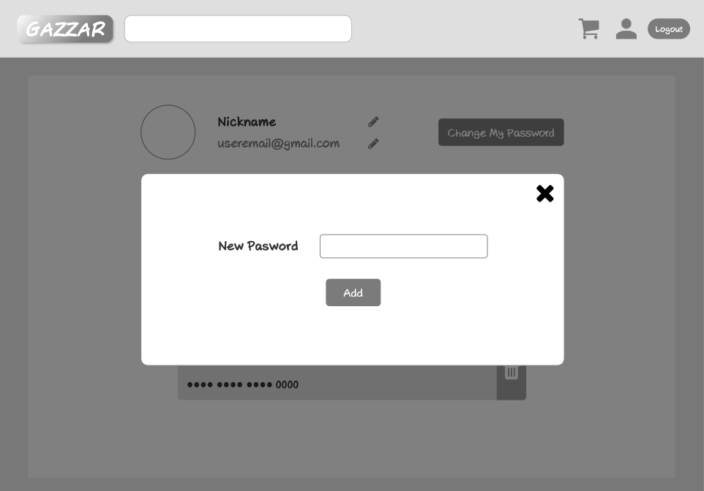

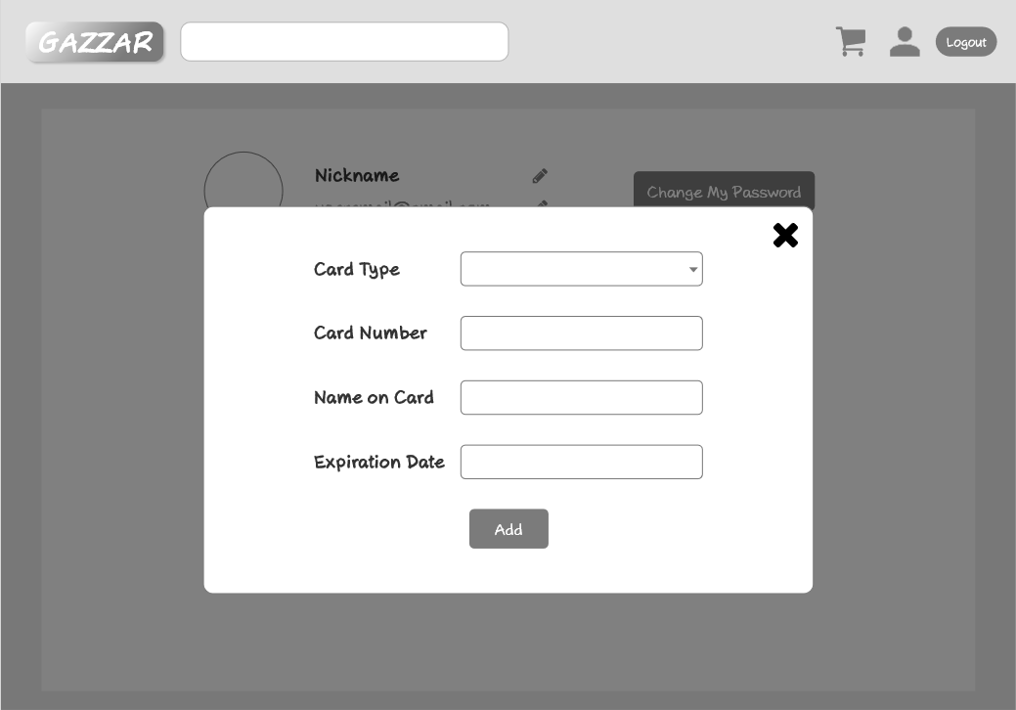

### 4.2.6 Search Result Page

Users can use the search function in the Page containing search box, search all products of the website by entering characters, and jump to the Search Result Page. If no search result is found, the search result area is empty, otherwise, the matching product information block is displayed. The left list is search option. User can tick them to choose the result shows by ascending or descending on price. Users can also choose what type of product to be shown at search result by ticking the product type.

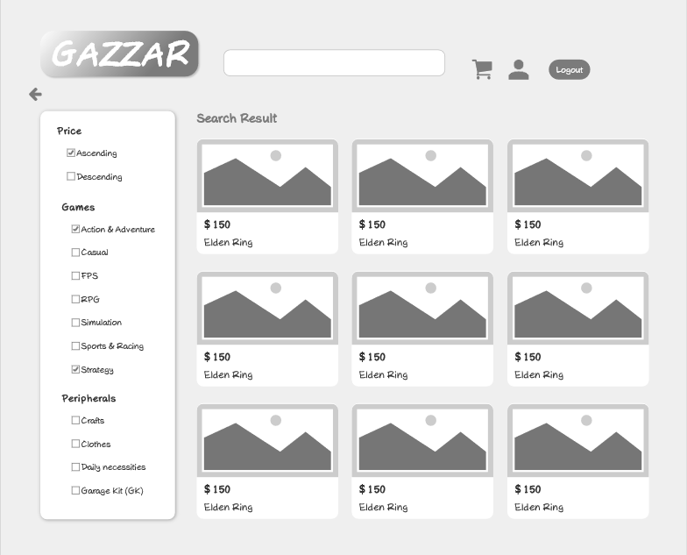

### 4.2.7 Surprise Store Page

Registered users can access their own Surprise Store Page through the rolling recommendations/ activities module of Home Page. The Surprise Store Page mainly provides user specific discounts and personalized recommended products. And the user can click on each item to check further details.

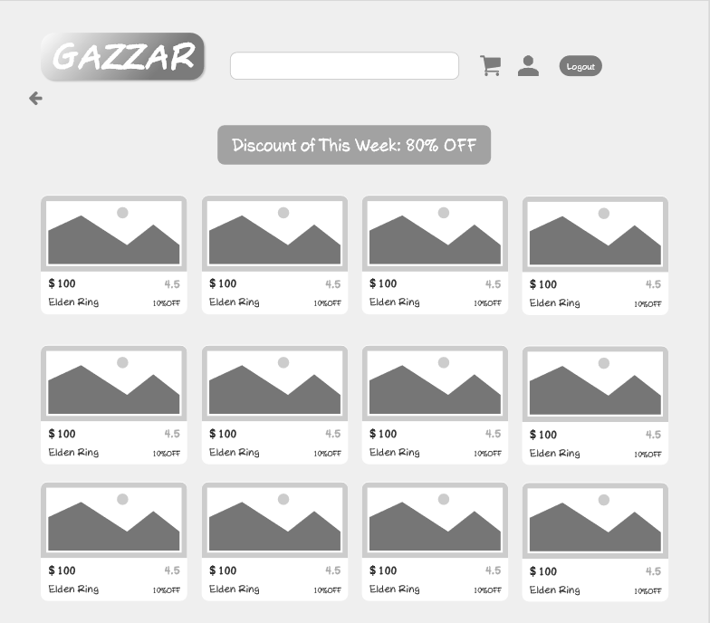

### 4.2.8 Description Page

Users can access Product Details Page through Home Page, Search Results Page, and Surprise Store Page. The Product Details Page mainly introduces the basic information of the specific product such as name, rate, price, type, stock, picture, product detail and other buyers' comments. User can choose product quantity by clicking on "-" and "+" icons, or filling number in the box. Users can add the product to the cart by clicking on "add to cart" button. If users click on ‘Buy Now’ button, the system will jump to the checkout page. If users click '<—' button, they will be back to Home Page. If the product is on discount, this page will show the product's original price, now price and discount. If users click comments, the page will show each comment and its rate.

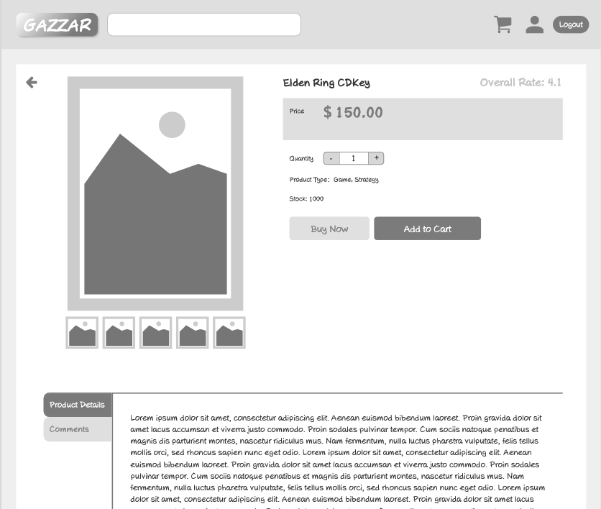

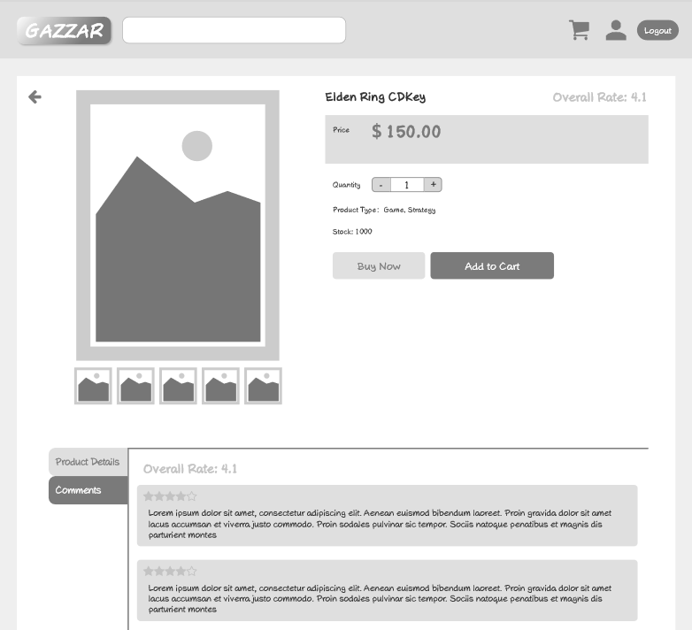

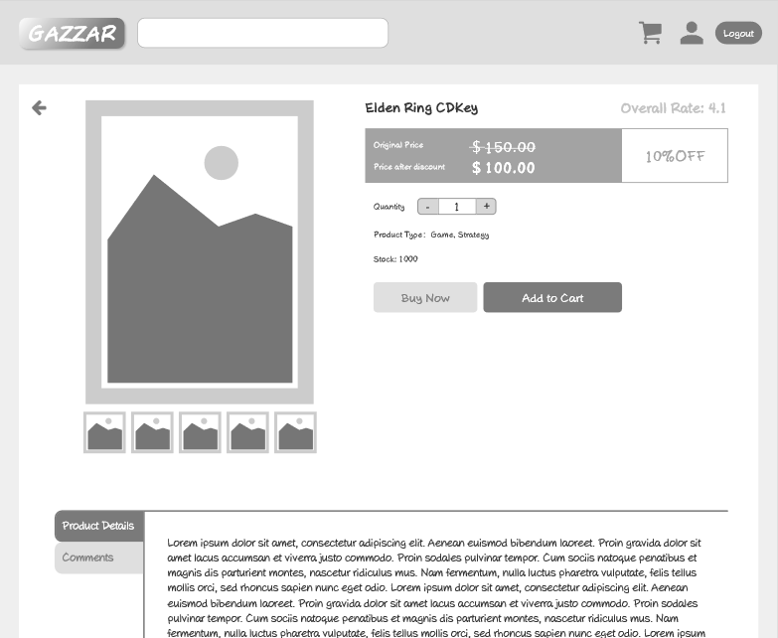

### 4.2.9 Checkout Page

Check out page shows what product you want to buy, original price, discount, final price and payment information. User can also click "<—" button to be back to Last Page. If users click 'Place Your Order in AUD' button, the system will jump to Bank Payment Page. If users want to add a payment option, they can click "+" icon.

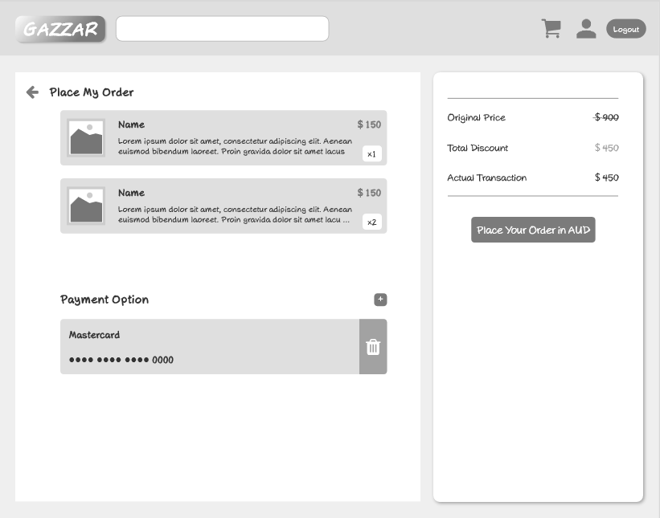

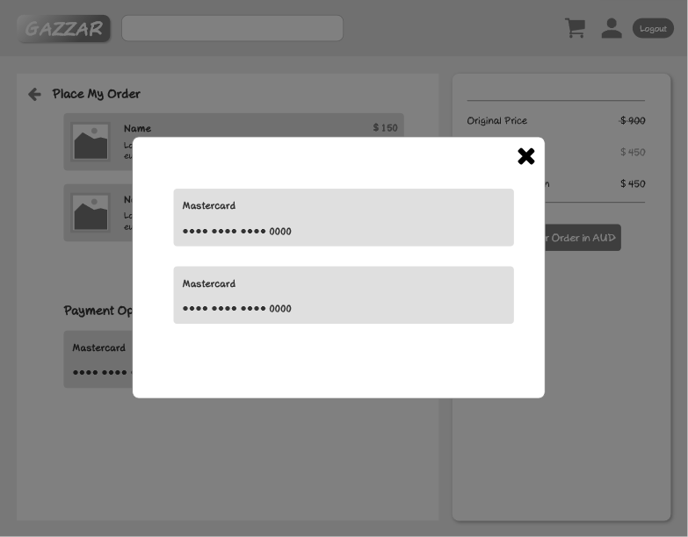

### 4.2.10 Cart Page

The user can access the shopping Cart Page on any page containing the shopping Cart Icon. If the user has not added product to the shopping cart, the empty page will be displayed. On the contrary, the products of the shopping cart will be displayed. The page will show products' names, price, quantity, description. If users click the product, the page will jump to the product's page. If users want to check out, they can tick which products to buy and click "check out" button, then the page will jump to the checkout page. User can also click "<—" button to be back to Last Page.

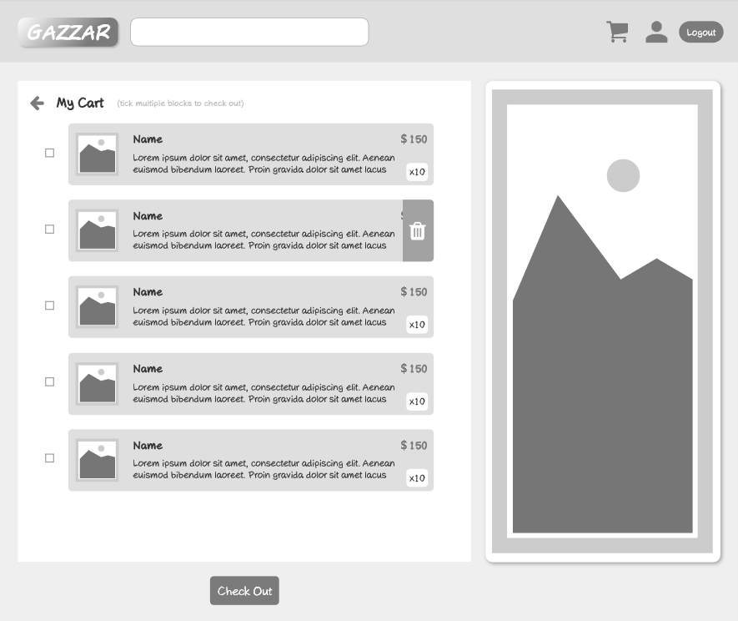

### 4.2.11 Order Page

Users can access their own History Order Page through the Home Page. If the user has no order history, a blank page will be displayed. If yes, the order list is displayed. In order to facilitate users' view, the system displays the order information in units of products. It shows products' names, price, quantity, description. If users click the order, the page will jump to the order information page. If users want to delete some order records, they can click the "trash" icon. The right of the page are recommended products. If users click them, the page will jump to the product's detail page. User can also click "<—" button to be back to Last Page.

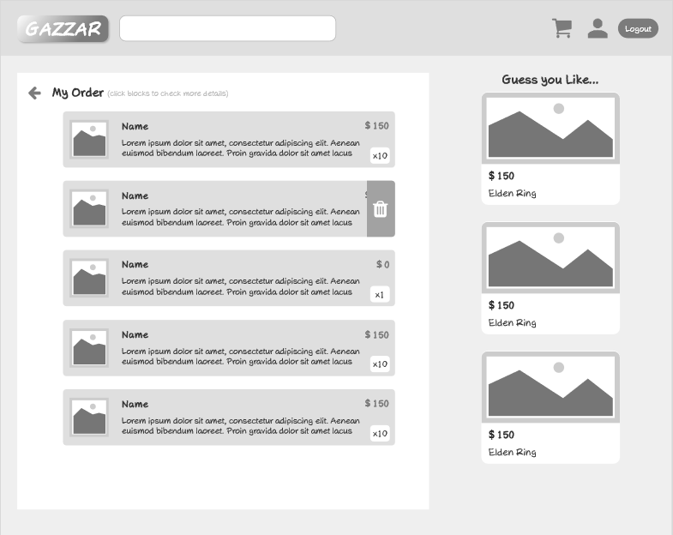

### 4.2.12 Order Details Page

Users can click the order in the history order list to access the specified order details page. The details page will contain product information, CDKEY, order number, trading date, product name, discount, quantity, unit price, price after discount, my rate and my comment. If users have rated and finished writing, they can click "Finish" button to submit.

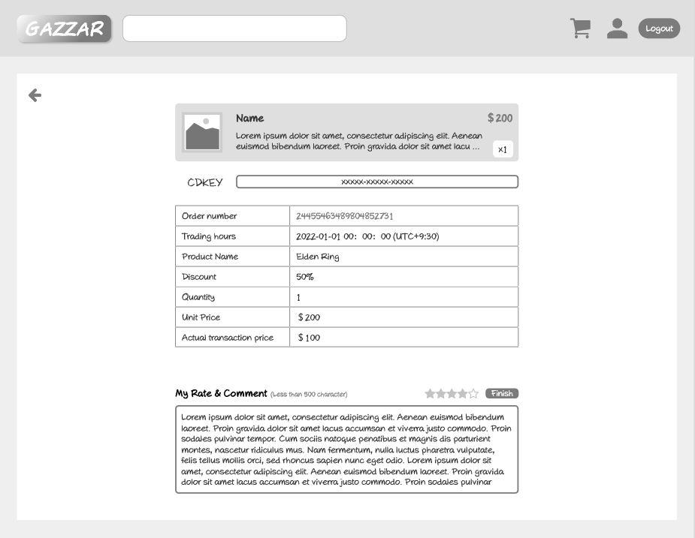

### 4.2.13 Lottery Page

After successful payment, users would be redirected to the lottery page. User could select 'START' button to start the lottery game. If one of products is successfully selected, a congratulation message would pop out. User could click 'here' button to move on the Order Page to check out the lottery prize.

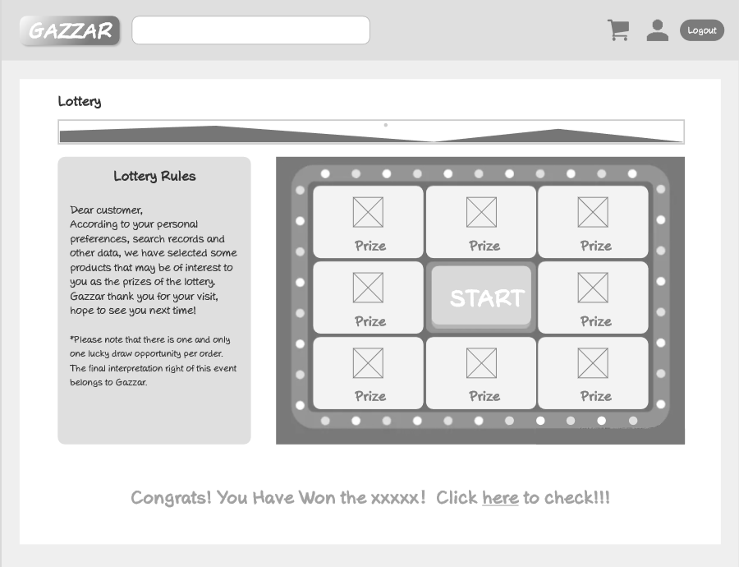

### Login Page

Login page asks customers to fill Email and password that they registered, then click Login, so that customers can succeed to View Sales page.

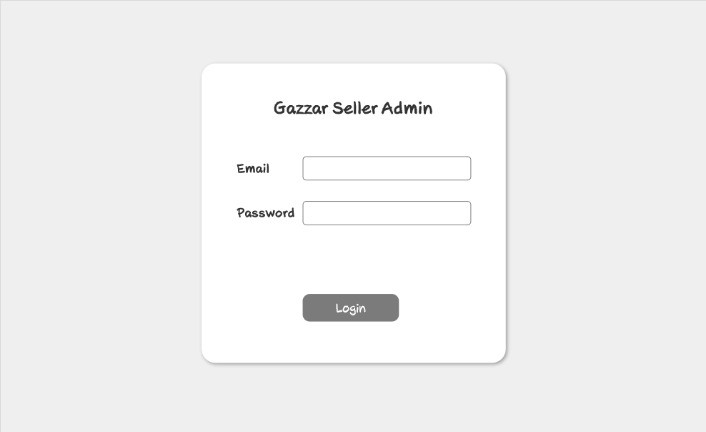

### 4.2.15 View Sales Page

After logging in, the administrator can access the View Sales Page through the management option on the left of the page by clicking 'Overview'. All kinds of digital sales information will be shown on this page. Additionally, there is a left bar (including View Sales, Games Management, Peripherals Management, Order Management, User Management, Stock Management).

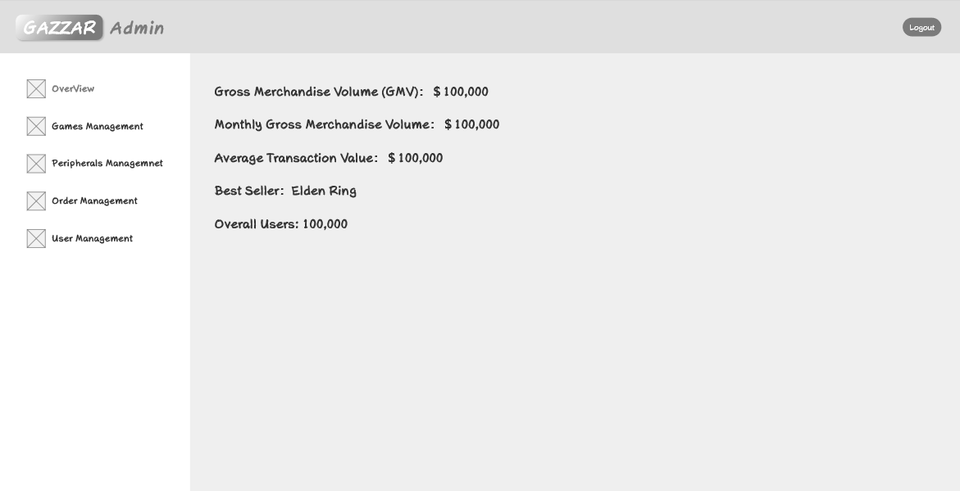

### 4.2.16 Game Management Page

The administrator can access the Games Management Page through the management option on the left of the page. Admins can view the product details via the form. Admins can search the specified product by the search bar, or just choose the specific State / Type by the drobox. Besides, admins will be redirected to the Add Products Page by clicking 'Add new Product' button to add a new product. Admins can delete the product by clicking 'Delete' button. Additionally, admins can edit the specific product's details and redirect to Edit Product Page by selecting 'Edit'.

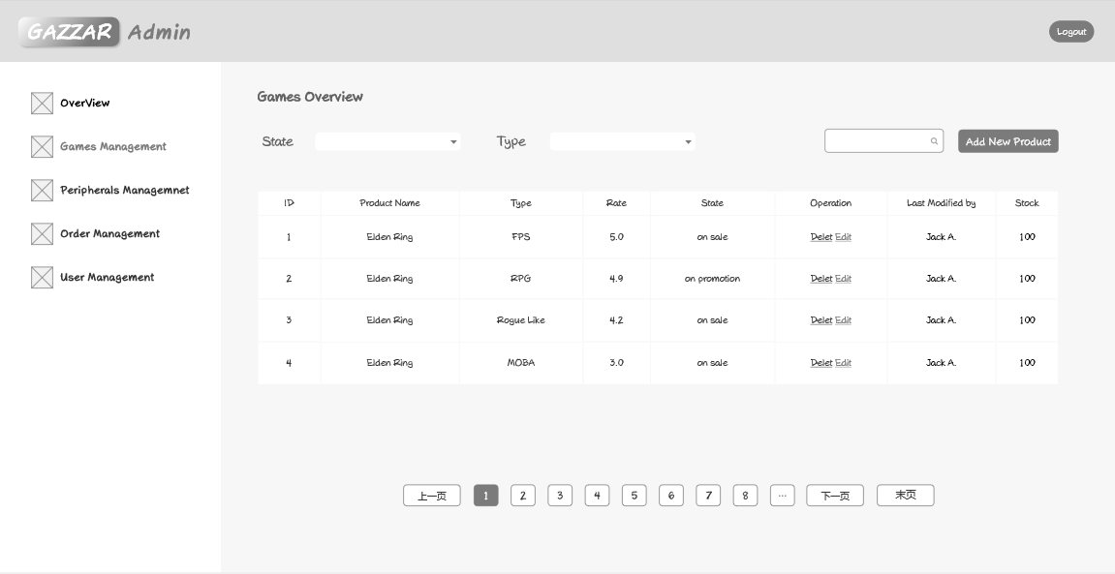

### 4.2.17 Add Product Page

In the Add Product Page, admins could input the specific product details (including price, name, photo, and description). After selecting 'submit', all the details would be uploaded, and the page would be redirected to the Game Management Page. Management Options / Logout will visit the designated page

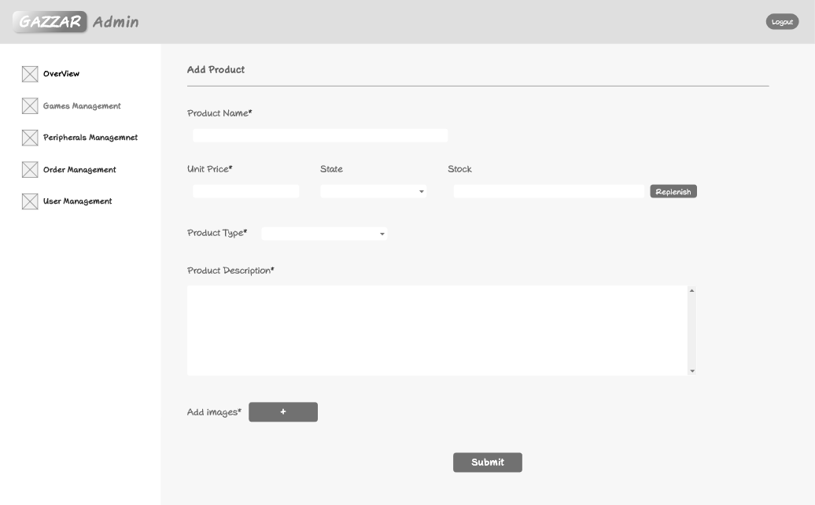

### 4.2.18 Edit Product Page

In the Edit Product Page, admins could edit the specific product details (including price, name, photo, and description) . After selecting 'submit', all the details would be uploaded, and the page would be redirected to the Game Management Page. Management Options / Logout will visit the designated page

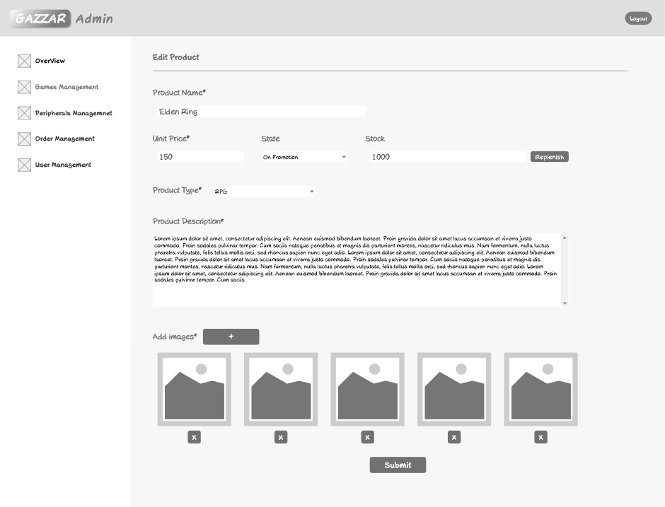

### 4.2.19 Peripherals Management Page

The administrator can access the Peripherals Management Page through the Peripherals management option on the left of the page. Admins can view the product details via the form. User can search the specified product by the search bar, or just choose the specific State / Type by the drobox. Besides, admins will be redirected to the Add Products Page by clicking 'Add new Product' button to add a new product. Admins can delete the product by clicking 'Delete' button. Additionally, admins can edit the specific product's details and redirect to Edit Product Page by selecting 'Edit'.

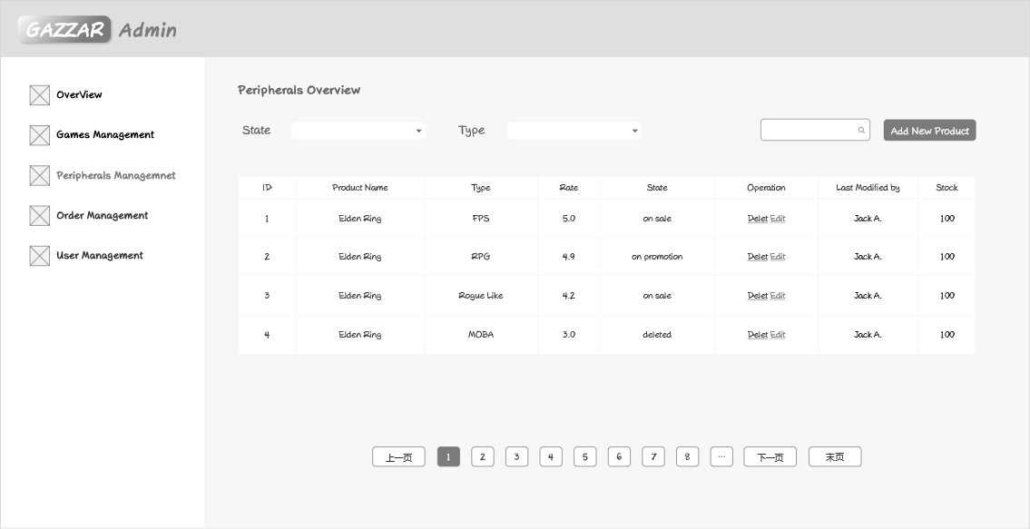

### 4.2.20 Order Management Page

The administrator can access the Order Management Page through the Order management option on the left of the page. Admins can view the order details via the form. User can search the specified order by the search bar.

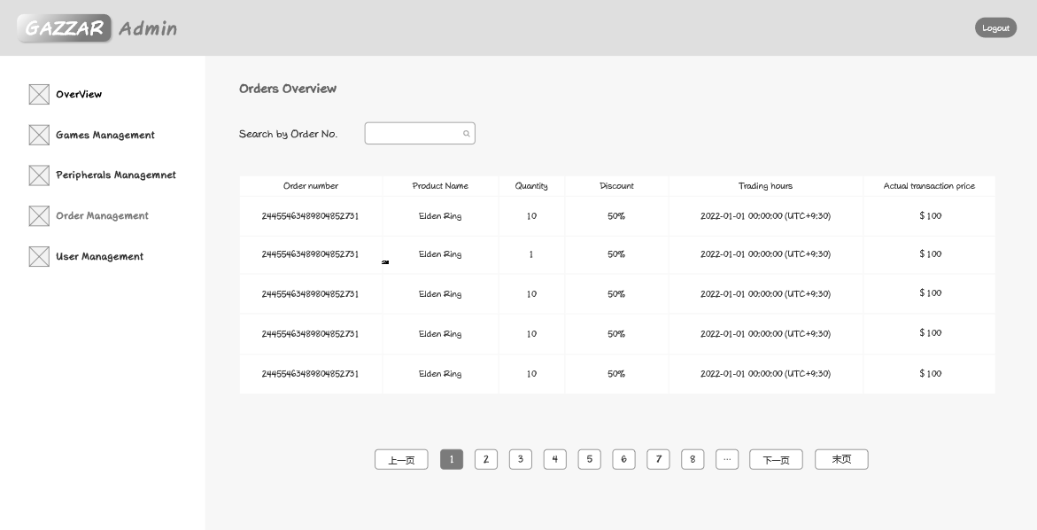

### 4.2.21 Admin Management Page

The administrator can access the Admin Management Page through the Admin management option on the left of the page. You can view all the admins' details via the form (including emails and password). You also can delete the admin account by clicking 'Delete' button. Additionally, you can Register a new admin account by typing in emails and passwords and clicking 'Register New Admin' button.

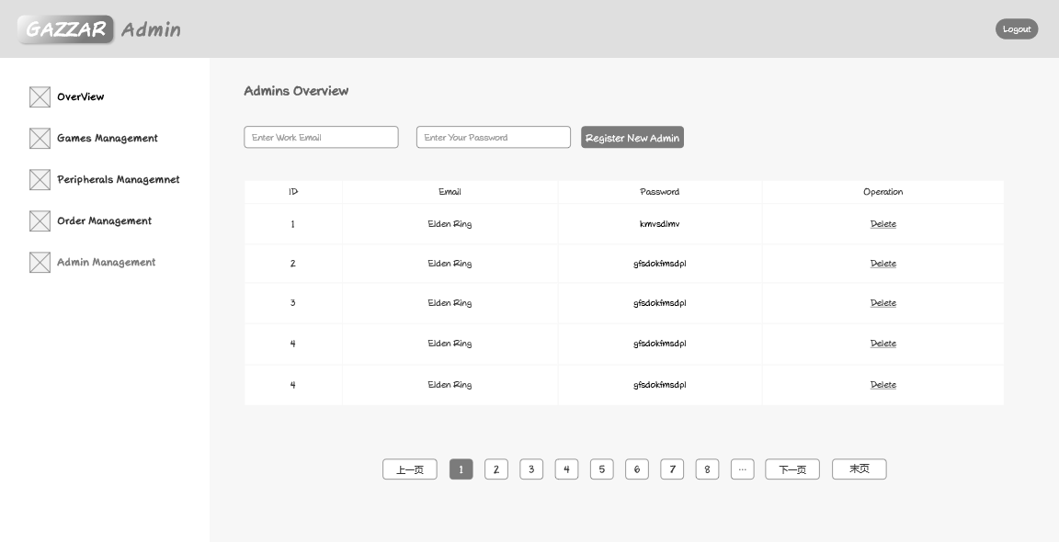

## 4.3 System Architecture

Our game e-commerce website Gazzar is obeying the system shown below (Figure 4.3). Users and admins are able to access the website page from the browsers of computer based on **JavaScript**. All the actions including purchasing games or related products for users (buyer) and managing products for admins (sellers), are passed to backend by the components implemented on the frontend web platform. Additionally, the request results made by users and admins would be passed to and displayed by frontend gaming web.

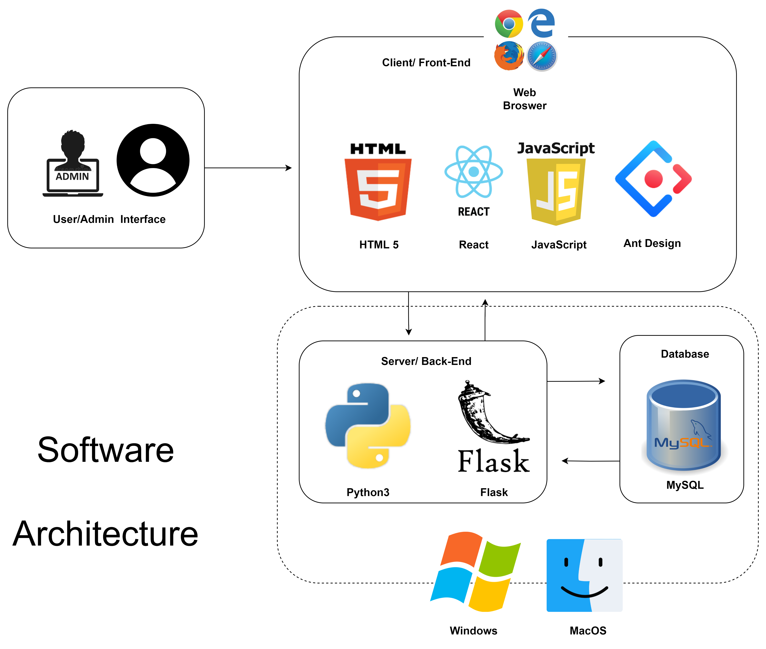

Figure 4.3

### 4.3.1 Front-end:

Frontend website is coding based on **JavaScript**, **HTML5**, **React** and **CSS.** And planning to use a few third-party libraries to decorate the website (**Ant Design**). React takes a unique way of manipulating the DOM compared to other frameworks. It does not operate directly on the DOM but introduces a concept called the virtual DOM, which is interposed between the JavaScript logic and the actual DOM. This concept improves web performance. During UI rendering, React implements local updates to the actual DOM through micro-operations in the virtual DOM. In addition to being fast, React has the advantages of cross-browser compatibility, modality, etc. Gazzar's presentation would be divided into two platforms (Buyer platform, seller platform) specific for the users and admins.

### 4.3.2 Back-end:

* **Basic Framework:**

We are going to use **Python** as the programming language for faster feature implementation, broader API access and better compatibility with flask.

**Flask API** is going to be used as a connection between Front-end and Back-end trough a few backend functions with the Unique URL route. For example, the buyer is able to access a Cart List from the URL http://localhost:${BackendPortNumber}/${user_id}/cart. In this case, the front-end browser would send a request to the back end, after receiving the request, the back-end server would send a branch of required data to front-end, then the website would display it. By processing the data by back-end, then response time of browser and memory usage would be reduced. Additionally, database access would be exclusive while writing as each request would be isolated individually and maintain the integrity of database.

* **Back-end Architecture**

1. Buyer layer

2. Admin layer

* **Back-end database**

In both layers, we need to fetch and update data in database. To simplify programs and improve development efficiency, we are using **MySQL**. In the project, we are going to permanent data storage. And all the data for example, gaming products, user and admin accounts information and order details would be stored in a readable and writable database along with the server. The data would be persisted between server shutdown and server restart. This feature helps to reserve users’ information during system upgrade and maintenance.

* **Authentication and Authorization**

In our project, there are serval account authentication requests for users (buyers) and admins (seller). We are going to use JWTs to realize this feature.

Our gamming e-commerce website would be tested on both Windows and MacOS, realizing an excellent stability and fast response time and providing an excellent gaming and relative products purchasing experience for each game player.

# Reference list

Clement, J., 2021. Number of peak concurrent Steam users 2013-2021. *Statista*. Retrieved from <https://www.statista.com/statistics/308330/number-stream-users/>

Newzoo, 2020. 2020 Global Games Market Report. *Newzoo*. Retrieved from <https://newzoo.com/insights/trend-reports/newzoo-global-games-market-report-2020-light-version/>

Tighe, D., 2022. Bandai Namco's global revenue 2006-2021. *Statista.* Retrieved from <https://www.statista.com/statistics/217482/annual-net-sales-of-namco-bandai/>

Wijman, T., 2021. The Games Market and Beyond in 2021. *Newzoo*. Retrieved from <https://newzoo.com/insights/articles/the-games-market-in-2021-the-year-in-numbers-esports-cloud-gaming/>